ACSL
American Computer Science League
2007 - 2008

All-Star

Short Round Questions
A. 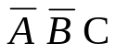
B. 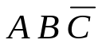
C. 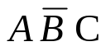
D. 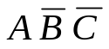
E. None of the above

- Boolean Algebra
Simplify:
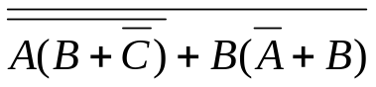

2. Digital Electronics
Let € be a gate with 3 inputs that is true if only one input is true.
Let ◊ be a gate with 3 inputs that is true if at most 2 inputs are
true. How many ordered quadruples make the following circuit
true?
A. 11
B. 12
C. 13
D. 14
E. None of the above

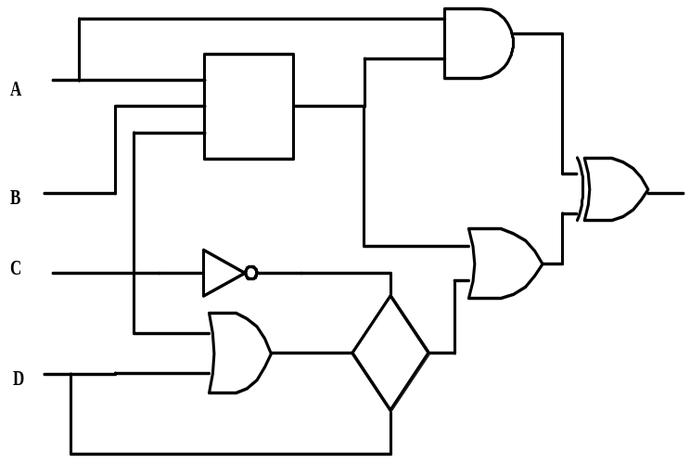

3. Prefix-Infix-Postfix
Define a # b = b - a and a % b = a + b
Evaluate the following postfix expression:
Note all numbers are single digits.

1 2 # 3 % 4 5 % # 5 % 6 # 7 8 # #

A. 4
B. 5
C. 6
D. 7
E. None of the above

4. Computer Number Systems
Find the values of A, B, and C that solve the following octal
cryptarithm. A, B, and C are unique octal numbers. A ≠ 0
and C ≠ 0. How many solutions are there?
A B C
+ A B
C 2 2

A. 1
B. 2
C. 3
D. 4
E. None of the above

5. Bit String Flicking
How many values of X (five bits long) solve the following
equation?

(RCIRC-3 (LSHIFT-2 X)) OR (11110 AND 11001) =
(RCIRC-3 (NOT X)) OR (11010 OR 10001)
A. 0
B. 2
C. 4
D. 6
E. None of the above

6. What Does This Program Do?
Given an initially empty array, A, what is the output after the program is run?
S = 0
FOR I = 1 TO 5
FOR J = 1 TO 4
IF J < I THEN A( I, J) = I ^ J
ELSE A ( I, J) = I + J
NEXT J
NEXT I
FOR I = 1 TO 5
FOR J = 1 TO 4
IF A(I,J)^0.5<>INT(A(I,J)^0.5) THEN
S = S + A(I,J)
NEXT J
NEXT I
PRINT S
END

A. 139
B. 147
C. 177
D. 202
E. None of the above

- Recursive Functions
Find 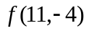 where [] is the greatest integer less
than or equal to , 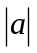= absolute value function and
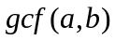=greatest common factor of and
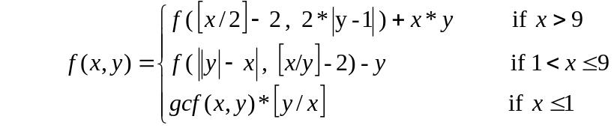

A. -37
B. -49
C. -51
D. -63
E. None of the above

8. Graph Theory
How many more cycles would there be from A if the
directed edges AE and BD were added to the directed graph
below?

A. 3
B. 4
C. 5
D. 6
E. None of the above
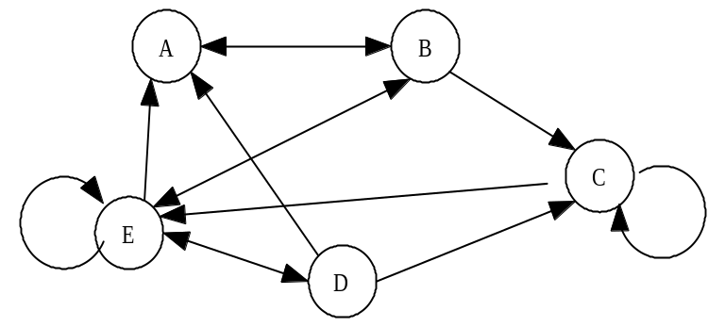

- Data Structures
What is the positive difference between the internal path lengths in the binary search trees of :

MARRIOTTSRIDGE and MARRIOTTSVILLE?
A. 4
B. 5
C. 6
D. 7
E. None of the above

A. (4 3)
B. (2 1)
C. ((4 3))
D. ‘(2 1)
E. None of the above
- LISP
Evaluate the following LISP expression:

(REVERSE(CDR ‘ ( (1 2) 3 4)))

- FSA and Regular Expressions
What is the length of the longest string that can be generated by the following regular expression, given that the string must contain at most 3 a’s and at most 4 b’s?

a b ( ( b c ) * a * U c b * ) a *
A. 7
B. 8
C. 9
D. 10
E. None of the above

- Assembly Language
After the code is executed, what is the final value of S?

S DC 0 LOAD I
A DC 5 ADD A
B DC 40 STORE I
I DC 1 LOAD B
TOP LOAD I SUB I
MULT A BG TOP
ADD S PRINT S
STORE S END

A. 405
B. 560
C. 740
D. 950
E. None of the above

A. 405
B. 560
C. 740
D. 950
E. None of the above

